LAB TASK

Task 1

The assigned value of int exceeds its data type

Task 2

#include<stdio.h>

int main() {

int num1, num2, num3;

printf("Enter number 1: ");

scanf("%d", &num1);

printf("Enter number 2: ");

scanf("%d", &num2);

printf("Enter number 3: ");

scanf("%d", &num3);

if (num1 > num2 && num1 > num3) {

printf("The largest number is num1");

}

else if (num2 > num1 && num2 > num3) {

printf("The largest number is num2");

}

else {

printf("The largest number is num3");

}

}

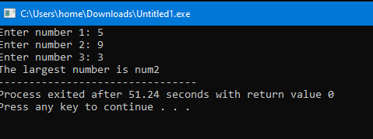

Task 3

#include<stdio.h>

main()

{

float LocalCurrency, ExchangeRate, ForeignCurrency;

printf("Enter amount to be converted: ");

scanf("%f", &LocalCurrency);

printf("Enter exchange rate: ");

scanf("%f", &ExchangeRate);

ForeignCurrency = LocalCurrency \* ExchangeRate;

printf("Converted amount is: %f", ForeignCurrency);

}

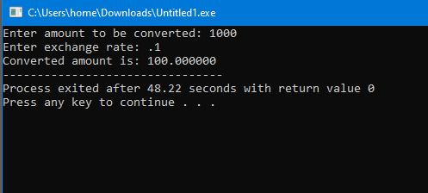

Task 04:

#include<stdio.h>

int main() {

int number;

printf("Enter a number: ");

scanf("%d", &number);

if (number % 2 == 0) {

printf("The number is even");

}

else {

printf("The number is odd");

}

}

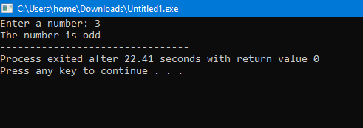

Task 5

#include <stdio.h>

int main() {

float originalPrice, discountRate, finalPrice;

printf("Enter the original price (between Rs. 100 and Rs. 50,000): ");

scanf("%f", &originalPrice);

if (originalPrice < 100 || originalPrice > 50000) {

printf("Error: Original price must be between Rs. 100 and Rs. 50,000.\n");

return 1;

}

printf("Enter the discount rate (between 5%% and 30%%): ");

scanf("%f", &discountRate);

if (discountRate < 5 || discountRate > 30) {

printf("Error: Discount rate must be between 5%% and 30%%.\n");

return 1;

}

finalPrice = originalPrice \* (1 - discountRate / 100);

printf("Final price after discount: Rs. %.2f\n", finalPrice);

return 0;

}

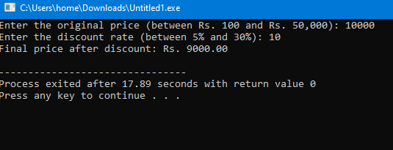

Task 6

int main() {

float Height, Radius;

float Pi = 3.14159;

float Volume;

printf("Enter Radius: ");

scanf("%f", &Radius);

printf("Enter Height: ");

scanf("%f", &Height);

Volume = Pi \* Radius \* Radius \* Height;

printf("Volume is: %.3f\n", Volume);

}

